Problem 2:

A. Build a NN for binary classification with **early stopping** criteria based on validation loss. Evaluate your model on the test data. Construct a confusion matrix. Present learning curve and include some examples of your prediction

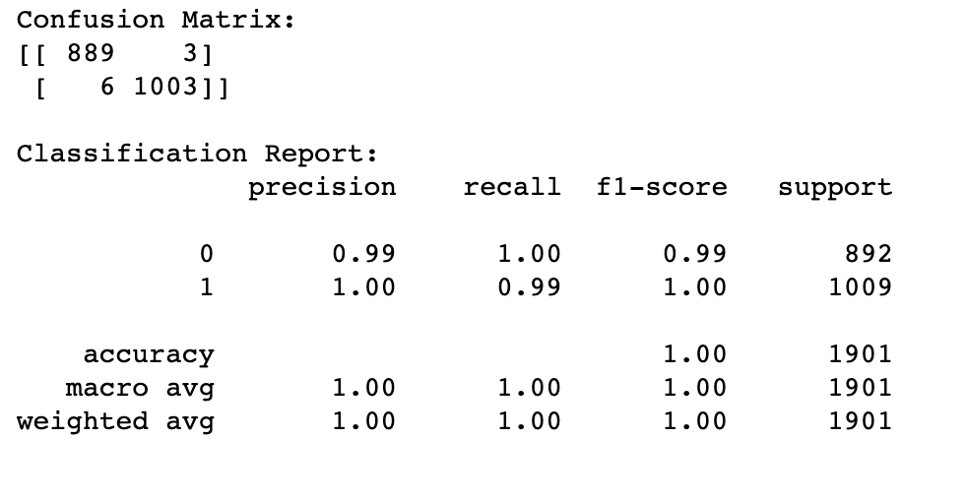 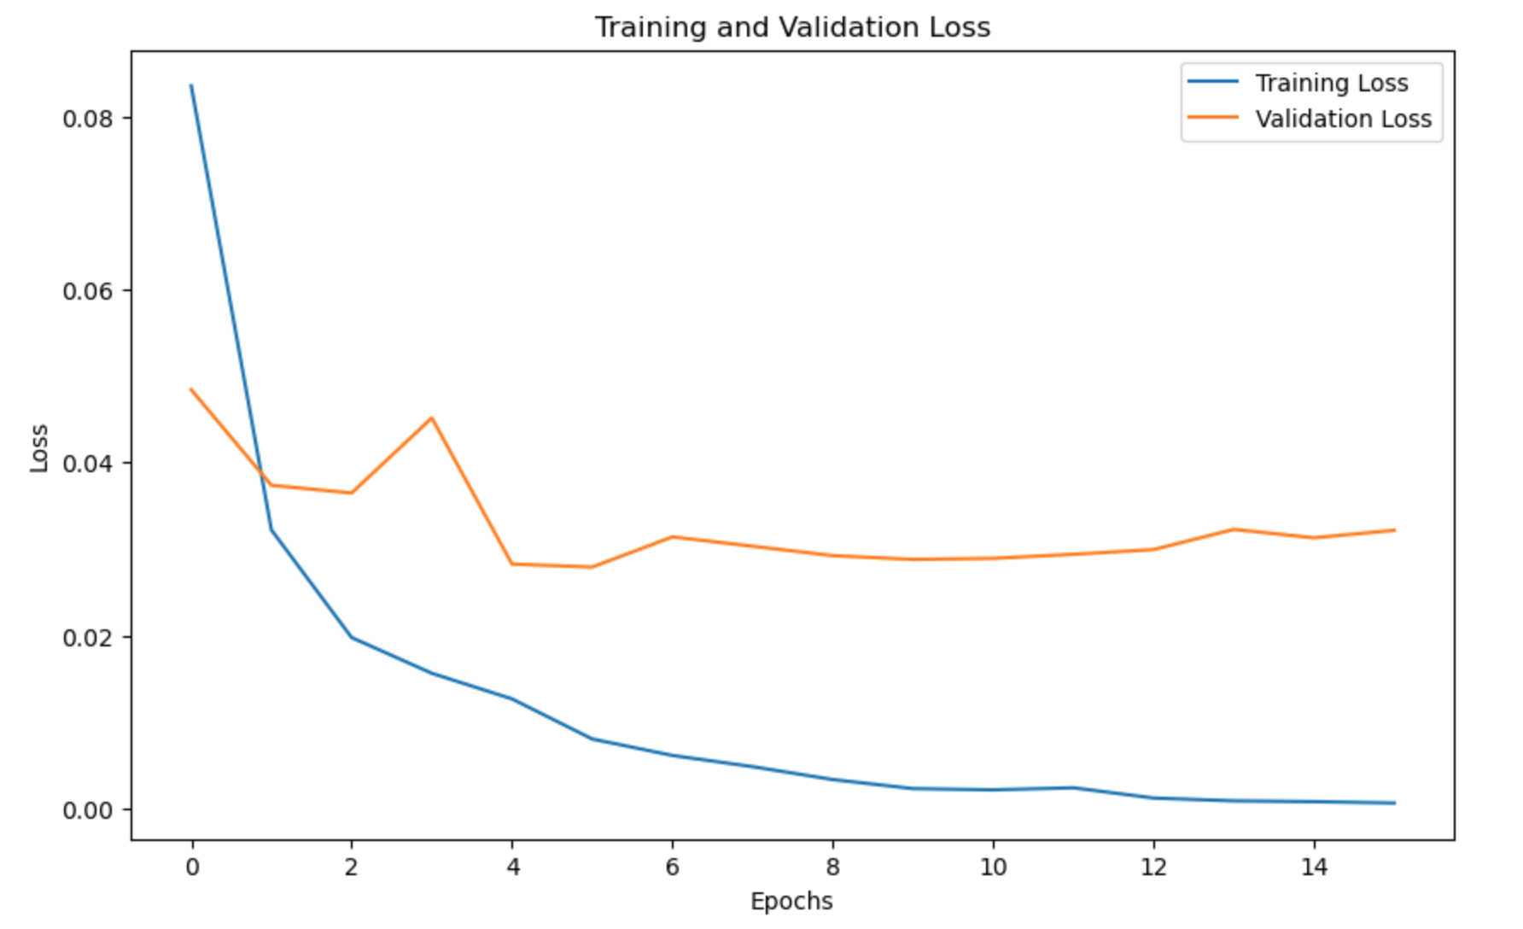

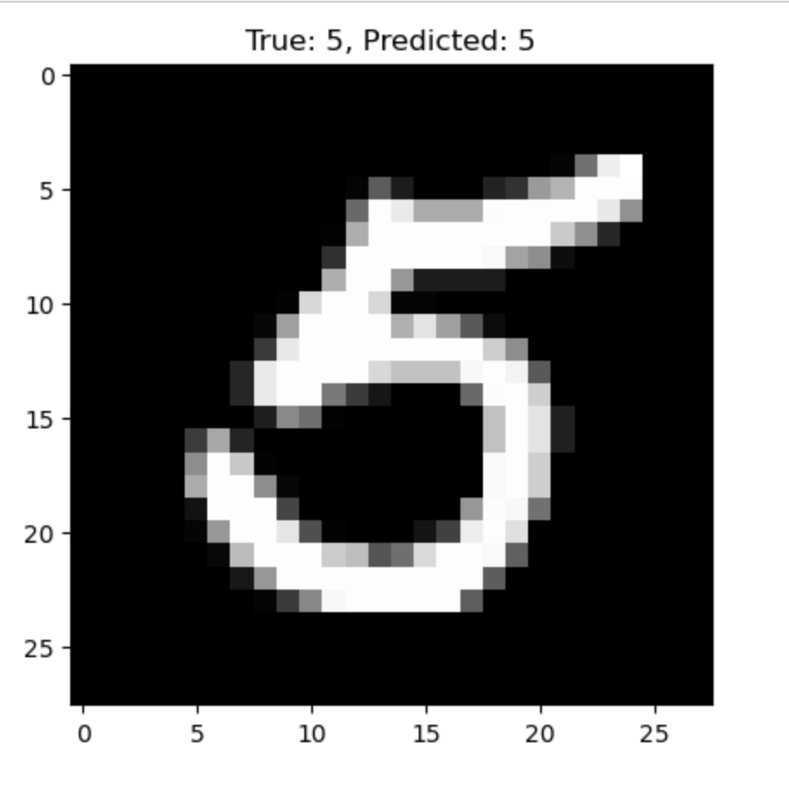 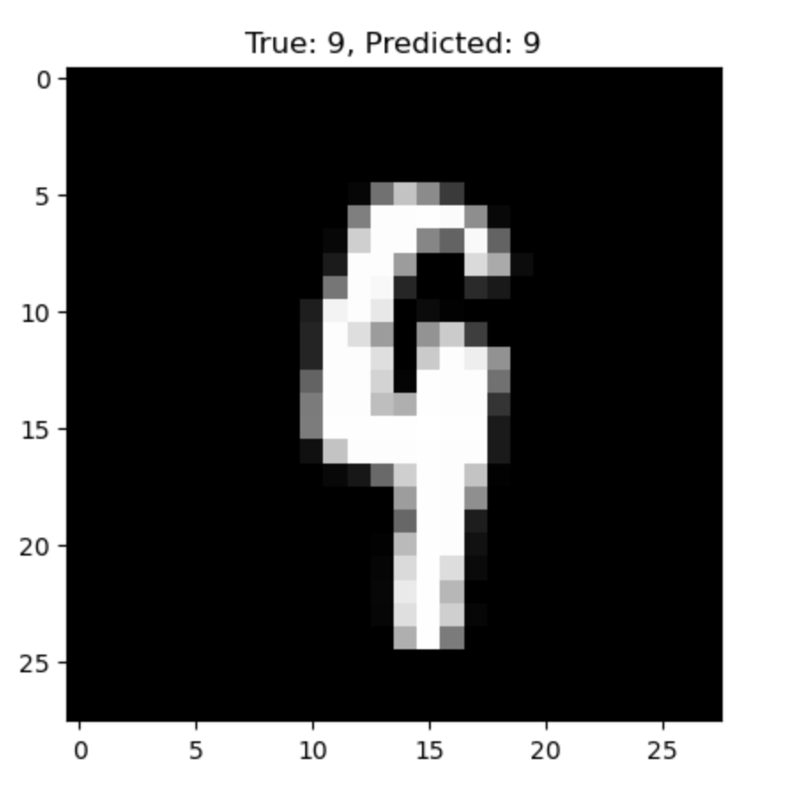

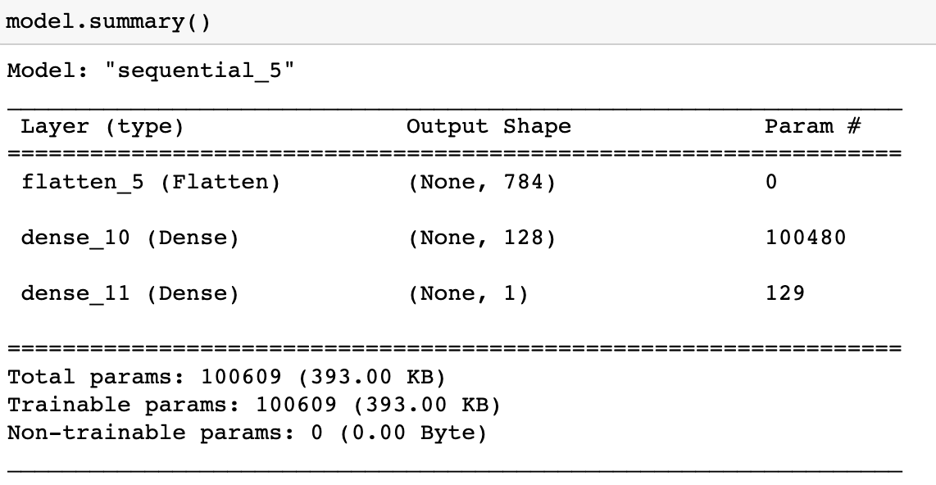

* 1. B. Build three NNs for binary classification using three **different weight initializers** held other hyperparameters constant. a. Construct three different confusion matrices
  2. b. Show three different learning curves and explain any differences
  3. 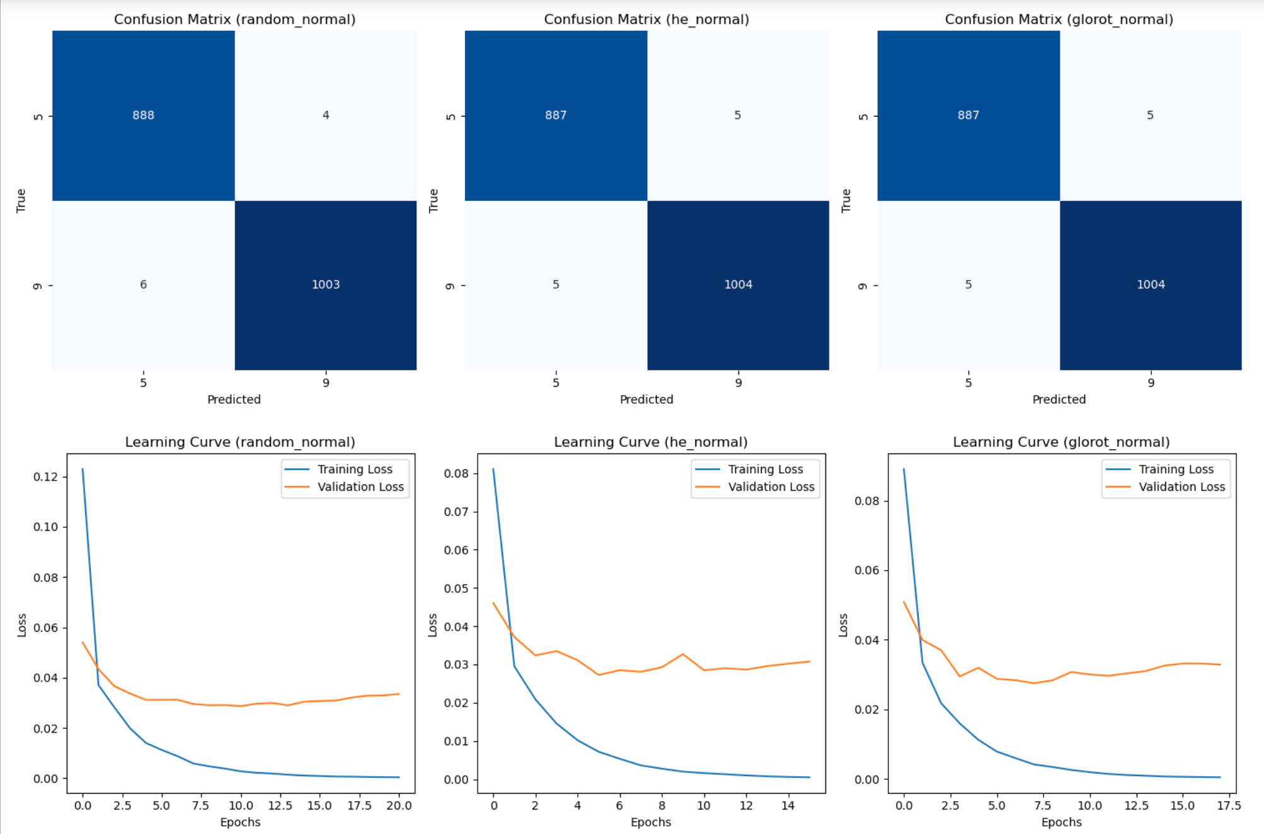

**Confusion Matrices**: The confusion matrices show how well each model is performing in terms of true positives, true negatives, false positives, and false negatives. Different initializers may result in different confusion patterns.

**Learning Curves**: Learning curves display the training and validation loss over epochs for each model. Differences in learning curves can indicate variations in training behavior, such as convergence speed or overfitting tendencies.

* 1. c. Show accuracy using bar plots and explain – _if there any difference in results for using three different initializers
  2. 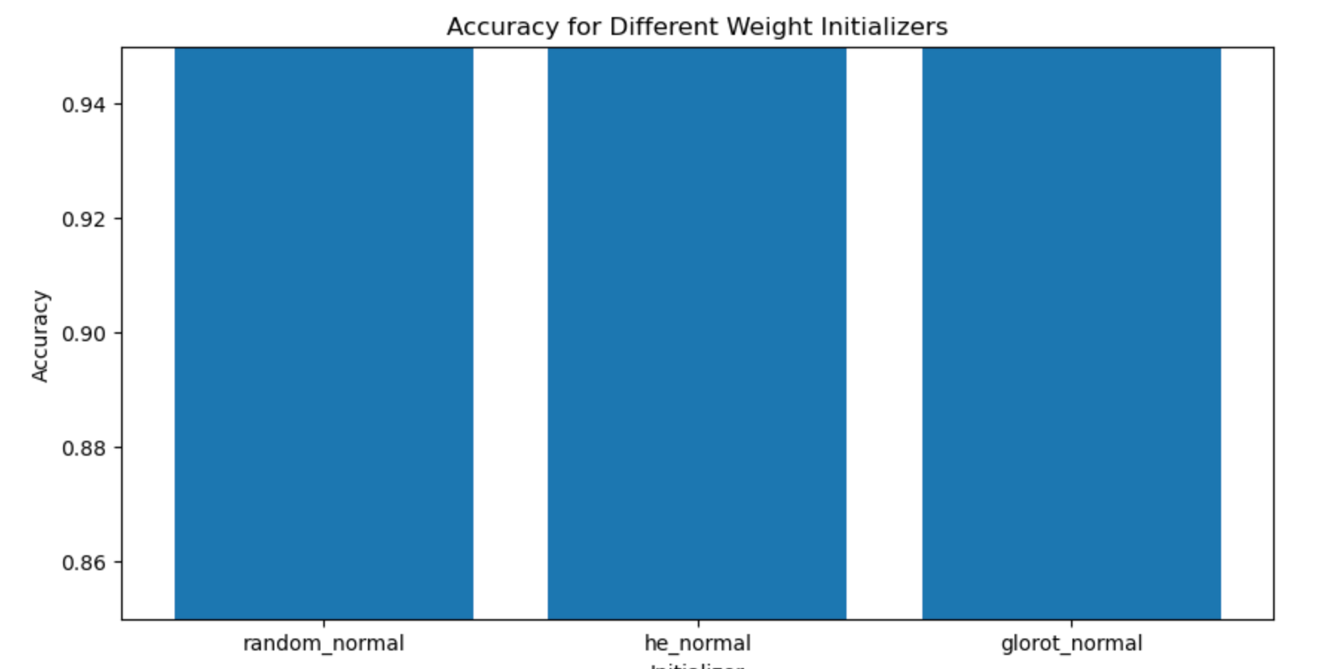

**Accuracy:** The bar plot of accuracy shows how well each model performs in terms of overall accuracy. It allows you to compare the models directly.

By using different weight initializers, you can observe how these initializations impact the model's performance and training behavior.

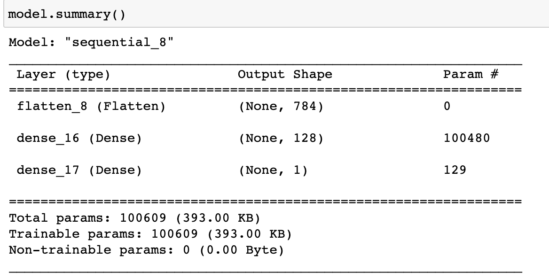

Problem 3**:** Build a NN for multi-class classification considering all the classes (10 classes) in the MNIST digit dataset: consider **early stopping criteria based on the validation loss** and finally construct confusion matrix and discuss the results.

